**Operating Systems Lab-2**

**Shell Programming (Part I)**



Submitted By: **Awais Saddiqui**

Registration# **21pwcse1993**

Section: **“A”**

Submitted to:

**Mam Madiha Sher**

**Department of Computer Systems Engineering**

**University of Engineering and Technology, Peshawar.**

**Operating Systems Lab**

**Objectives:**

The aim of this laboratory is to learn and practice SHELL scripts by writing small SHELL programs.

The following are the primary objectives of this lab session:

* **Understanding what is a SHELL script.**
  + - What is a SHELL script.
    - Different kinds of SHELLs in UNIX
* **Why and where it is used**
* **First simple SHELL script**
* **SHELL variables**
  + - User Defined variables
    - System variables
    - Read only variables and wiping out variables
    - Assigning values to variables
    - Reading input

**Shell:**

Shell interface to the operating system is called a shell. The shell is the outermost layer of the operating system. Shells incorporate a programming language to control processes and files, as well as to start and control other programs.

**Shell scripts**

A shell script or a shell program is a series of commands put in a file and executed by the Shell. We will use shell to create shell scripts.

**Uses of Shell scripts**

1) Customizing your work environment. For Example, every time you login, if you want to see the current date, a welcome message, and the list of users who have logged in you can write a shell script for the same.

2) Automating your daily tasks. For example, to back up all the programs at the end of the day.

3) Automating repetitive tasks.

4) Executing important system procedures, like shutting down the system, formatting a disk, creating a file system etc.

5) Performing some operations on many files.

**Example 1:**

Save the file and type the file name in command line and the file is executed as follows.

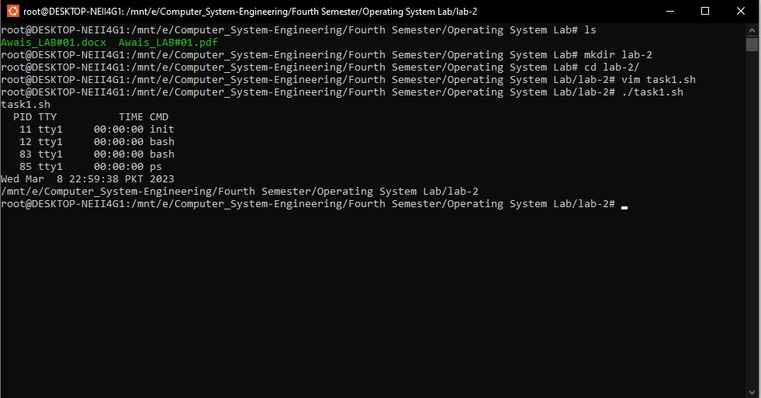

**Output:**

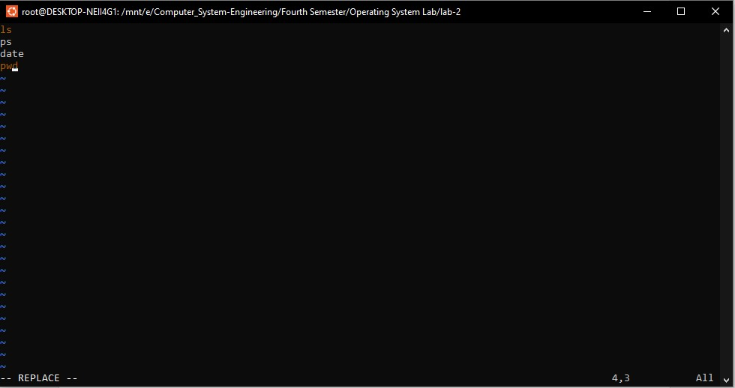

**Example 2:**

# Usage: SS2

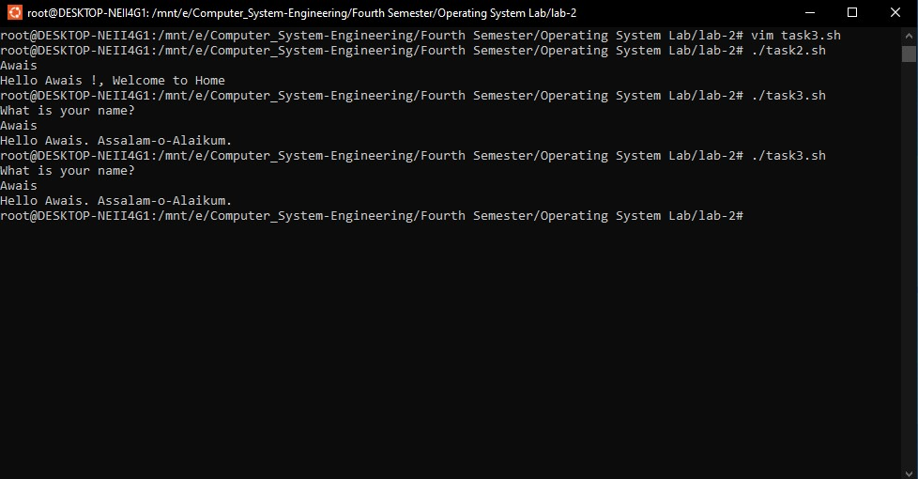

**Output:**

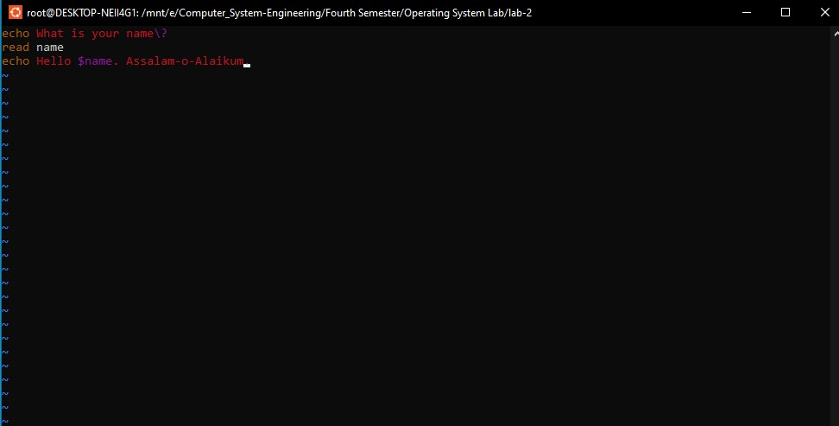

**Example3:**

# Usage: SS3

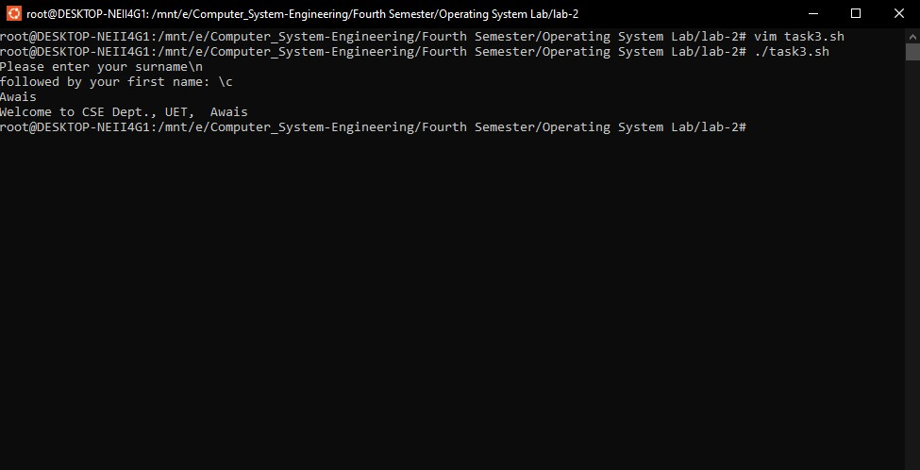

**Output:**

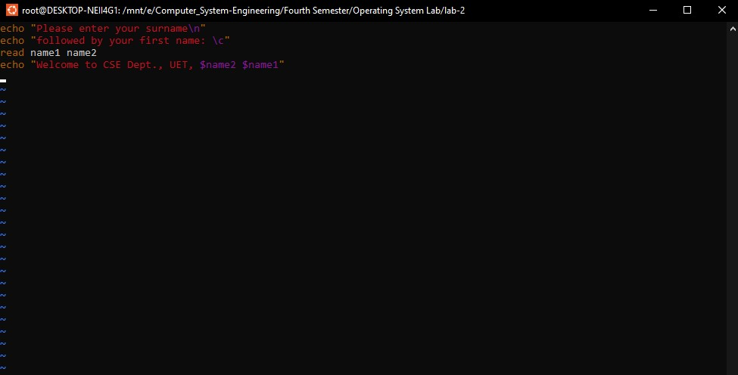

**Example4:**

# Usage: SS4

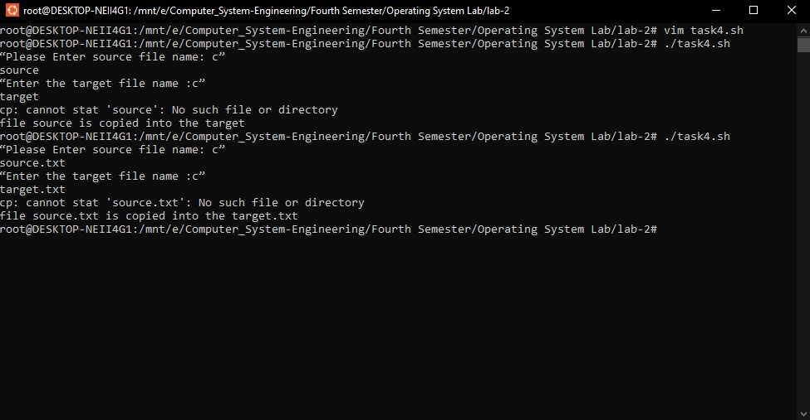

**Output:**

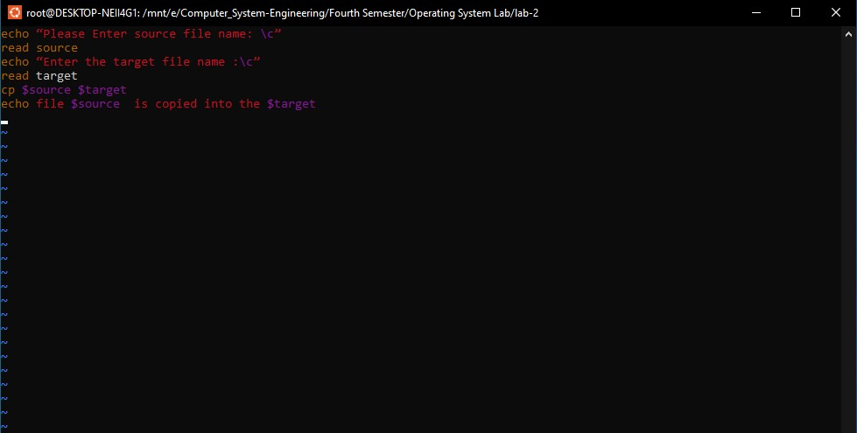

**Example 5:**

Usage: SS5

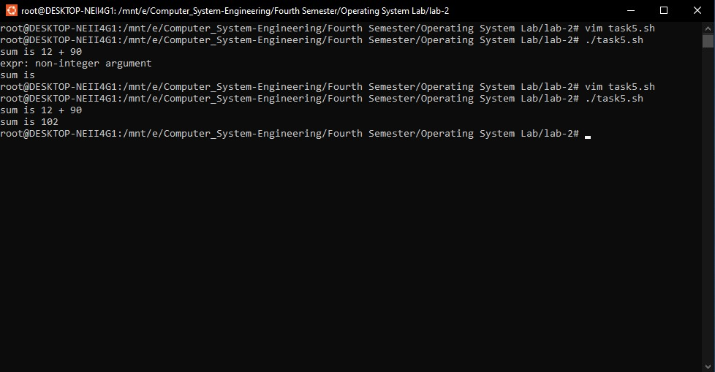

**Output:**

